EMORY PHYSICIAN ASSISTANT PROGRAM
DEPARTMENT OF FAMILY & PREVENTIVE MEDICINE
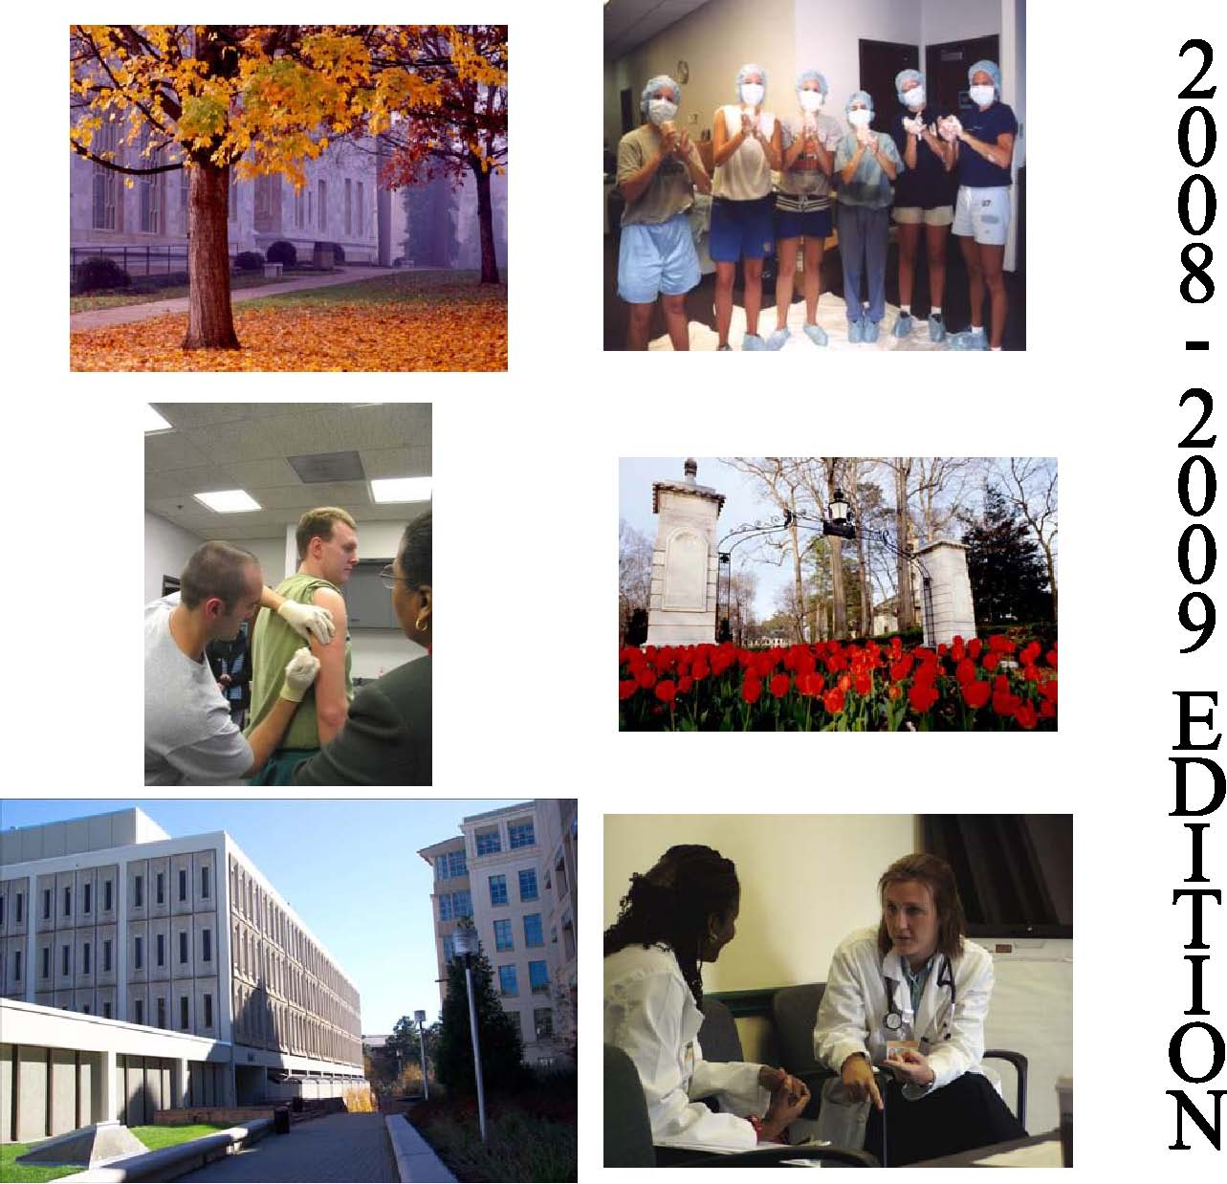

EMORY PHYSICIAN ASSISTANT PROGRAM

Clinical Preceptor Manual

© Emory PA Program
1462 Clifton Road, Suite 280
Atlanta, GA 30322
Phone 404.727.7825 • Fax 404.727.7836
TABLE OF CONTENTS
THE EMORY UNIVERSITY PHYSICIAN ASSISTANT PROGRAM MISSION 5
CURRICULUM 5
NATIONAL CERTIFICATION 6
OUTLINE OF STUDENT DUTIES ON CLINICAL ROTATIONS 7
GRADING AND EVALUATION 7
SITE VISITS 9
ROTATION SCHEDULE AND ABSENCES 10
STUDENT INJURY OR ILLNESS ON ROTATION 10
HOUSING AND MEALS 11
STUDENT ATTIRE 11

Dear Preceptor:
Physician Assistants often remember their clinical rotations as the highlight of their PA training; therefore, we thank you for your participation in this invaluable process.
This handbook is designed to provide information about the Emory University Physician Assistant Program and to offer guidance and educational objectives for supervising and grading students on their clinical rotations.
Our training program is twenty-eight months in length. The curriculum is divided into three segments: 15 months of didactic and advanced didactic work on campus; and 13 months of clinical rotations in rural and urban settings. While on rotations, students work both in office and hospital settings assisting in the care of patients, in much the same manner as interns do.
We appreciate your interest in our students and wish to make your task in supervising them as easy as possible. It is with that purpose in mind that this handbook was created. We have tried to answer common questions you may have; however, please feel free to call the PA Program office at (404) 727-1360 or 727-3832 at any time or visit our website at www.emorypa.org (follow the link on that page, “Our Preceptors” for additional resources).
Thank you for your commitment to PA education.
Emory PA Program
1462 Clifton Road, Suite 280 Atlanta, GA 30322
Phone: 404-727 7825
Fax: 855-EMORYPA (366-7972)

Director Clinical Educator - Metro Atlanta
Catherine W. Dragon, PA-C, MMSC
404-727-3028 or 404-727-3832
catherine. dragon@ emory.edu

Clinical Educator – outside Metro Atlanta
Liz Valdes, PA-C, MMSc
404-727-2581 or 404-727- 1360
lvaldes@emory.edu

THE EMORY UNIVERSITY PHYSICIAN ASSISTANT PROGRAM MISSION
The Emory University PA Program recruits, educates, and mentors a diverse group of students to become physician assistants providing quality health care. The Program emphasizes primary care and preventive medicine, and seeks to interest students in working in medically underserved areas. The Program uses didactic and clinical training, fosters an appreciation for research, and empowers faculty and students to be advocates for the physician assistant profession and for the delivery of primary health care.
OVERVIEW
The Emory University PA Program, implemented in September of 1971, functions within the Department of Family and Preventive Medicine of the School of Medicine, part of the Robert W. Woodruff Health Sciences Center.

CURRICULUM
Entering PA students matriculate at the beginning of the fall semester and initiate a comprehensive and demanding 28-month course of full-time study leading to the Master of Medical Science degree. The Program is designed to be completed over seven consecutive semesters. The first phase of the Program, commonly referred to as the didactic core, of basic health sciences as well as clinical medicine course work. This portion of the curriculum utilizes classroom, laboratory, and clinical settings to provide a thorough theoretical and practical background in both the basic and clinical health sciences. Courses during this period include: Anatomy, Biochemistry, Physiology, Introduction to Clinical Medicine, Microbiology, Pharmacology, Nutrition, Fundamentals of Clinical Medicine I, Fundamentals of Clinical Medicine II, Emergency Medicine, Clinical Laboratory & Diagnostic Methods I, Clinical Laboratory & Diagnostic Methods II, and Issues in Health.
There is an emphasis on research-oriented courses with the goal of providing the skills to interpret the medical literature. Students are required to research the literature on a clinical topic, write a review article, and submit their work to a peer-reviewed journal by the end of their senior year.

The next phase of the curriculum, the clinical core, includes rotations in the following required primary care areas: Emergency Medicine, Family Practice, Inpatient Medicine, Obstetrics and Gynecology, Geriatrics and Psychiatry, Pediatrics, and Surgery. During this phase of the Program, all students participate in supervised patient care, attending teaching rounds and medical-surgical conferences as they rotate on various services in Atlanta and other established clinical facilities around the state and the Southeast. In keeping with the mission of the Program, students will be exposed to a wide variety of practice settings and patient populations and all students are required to experience at least two rotations in clinical sites designated as medically underserved. During the clinical core experience, students are able to build the primary care knowledge and skill base that is necessary to function in all fields of clinical practice. They also gain exposure to a variety of clinical settings which enables them to make more informed decisions regarding the types of clinical practice they may wish to pursue upon completion of the Program.
Following the clinical core, students enter the elective clinical phase. The student may choose to spend the entire elective phase in primary care disciplines, or may divide this time into primary care and medical subspecialties and/or surgical subspecialties. During this time, students wishing to rotate through sites outside of those developed by the Program must first obtain permission from the Program.

NATIONAL CERTIFICATION
Emory PA students are eligible to apply and sit for the National Certifying Examination for Primary Care Physician Assistants upon graduation. This exam is developed by the National Board of Medical Examiners and administered by the National Commission on Certification of Physician Assistants (NCCPA). Such certification of competency by a nationally recognized organization provides the potential physician employer with acceptable evidence of graduate competency. Certification by the NCCPA is a prerequisite for state certification in Georgia and the majority of other states.
ACCREDITATION
ARC-PA The Emory PA Program is fully approved by the Accreditation Review
Commission on Education for the Physician Assistant.
PAEA The Emory PA Program is a member of the Physician Assistant Education Association, the exclusive national organization representing educational programs.
AAPA The American Academy of Physician Assistants recognizes the Emory PA
Program, its students, and its graduates.
CSBME The Emory PA Program is recognized by the Georgia Composite State Board
of Medical Examiners as fully approved.
ADMINISTRATION OF CLINICAL ROTATIONS
Prior to the beginning of the first rotation, the preceptor physician will be asked to complete a brief practice description, submit a resume, and sign a rotation agreement. This document is not binding and the preceptor may terminate the agreement if he/she deems it necessary. It is completed as a requirement for insurance purposes to demonstrate formal acceptance of the student on the rotation. Malpractice insurance is carried by the University to provide coverage for the student. A copy of the insurance certificate is available upon request.

OUTLINE OF STUDENT DUTIES ON CLINICAL ROTATIONS
The ideal preceptor is a person who enjoys teaching students and is dedicated to the perpetuation of the art of medicine. The University prefers that preceptor physicians be board-certified or board-eligible in the discipline in which the student is rotating. The normal duties of the student will include performing histories and physical exams, and developing appropriate treatment plans for patients in the office and in the hospital. Additionally, the student will perform some office laboratory procedures, learn diagnostic procedures, and assist with patient education as directed by the preceptor physician. Duties will vary depending on the type of rotation and subspecialty of the preceptor. On rotations that include inpatients, it is anticipated that the student will make daily rounds with the physician, and take night and weekend call with the physician. When possible, the student is expected to be on call every third evening and two weekends during the rotation, or as directed by the physician consistent with the rotation setting. It is desired that students be given the opportunity to evaluate patients in the emergency room. There is an emphasis on hands-on experience for students, and it is preferred that the preceptor physician permit this experience whenever possible.

GRADING AND EVALUATION
An evaluation form is completed by the preceptor physician for each student. The form will be mailed or Emailed to the preceptor prior to the end of the students’ rotation. Ideally, the preceptor will provide feedback to the student during and at the end of the rotation. It is requested that the preceptor be as candid as possible in his/her evaluation in order that the faculty can realistically assess the progress of our students. A letter grade based on the preceptor’s evaluation will be calculated by the PA Program.

Many preceptors find evaluation an unpleasant component of their community-based teaching. Evaluation is, however, a critical function of teaching. Evaluation helps assure that future clinicians possess appropriate knowledge, attitudes, and skills. Effective evaluation also helps a learner assess his or her strengths and weaknesses, identify strategies for improvement, and continue professional growth and development. The key to avoiding evaluation pitfalls is preparing for the evaluation throughout the rotation. When the evaluation process is fully integrated into the rotation, a student’s learning experience is enhanced, and a difficult task for the preceptor is made easier and more effective. Potential evaluation pitfalls may include:
  - “The halo effect”: When certain characteristics, either positive or negative, cause preceptors to overlook other important aspects of learner performance, e.g., an enthusiastic, caring learner with mediocre skills receiving high marks while a shy student with superior knowledge receives a lower grade.
  - “Oops”: Insufficient evidence describing a student’s shortcomings without providing specific incidents and ways in which the student could have done better. At the end of the rotation it can be hard to remember the details of such incidents without a system for recording observations.
  - “But you never TOLD me that”: Stating at the end of the rotation that the learner has fallen short of expectations when those expectations were not clearly stated during the rotation
  - “But I NEED honors!”: Finding out on the final day of the rotation about the student’s expectations and perceived needs for a particular grade or evaluation on the rotation.
  - “Uh-oh, should they pass?”: Realizing at the final evaluation that, despite significant efforts on the preceptor’s part, the learner’s performance has remained substandard throughout the rotation and that he or she should not pass. It is crucial to contact the school early in the rotation to get help.
  - “The Lake Wobegon effect”: Rating all students “above average,” which does not help the school or the student accurately assess the student’s strengths and weaknesses. The learner, future patients, and the profession may suffer.

Grading Tips
Here is a sample GRADE strategy to assist in the accurate and complete grading process of our PA students.
G—Get ready
- Review course expectations and the evaluation form
- Consider unique opportunities and challenges of your site
- What are your expectations for the learner?

R—Review expectations with learner
- Meet early in the rotation
- Determine learner’s knowledge and skill level
- Review program goals, your goals, and learner’s goals
- Describe the evaluation process

A—Assess
- Observe
- Record
- Provide feedback regularly
- Have learner self-assess

D—Discuss assessment at midpoint
- Formal meeting
- Learner and evaluator fill out preceptor evaluation form in advance
- Compare evaluations together
- Discuss differences and whether expectations are being met
- Plan for the rest of the rotation

E—End with a grade
- Schedule sufficient time
- Complete evaluation in advance
- Support your evaluation with examples
- Highlight items that can be worked on in the future
  - Complete the evaluation in advance so that you have time to carefully reflect on the learner’s knowledge, skills, attitudes, and improvement during the rotation, and room for further growth. It is difficult to do this effectively when the learner is looking over your shoulder.
- Support your evaluation with specific examples (this is where your notes can be helpful). Make sure your evaluation is future oriented; although this particular learning experience is ending, the learner’s education and professional career will continue.
- Include comments and specific examples of both positive attributes and areas for improvement on the written evaluation. Your comments help give the school a clear picture of the learner’s performance and are often incorporated into student progress reports. Make sure the comments and other aspects of the form reflect the learner’s overall performance.
- Complete any necessary paperwork as promptly as possible, while the experience is still fresh in your mind. Completing forms in advance of your final evaluation meeting gets most of the work out of the way before the learner leaves. You can also reserve the last 10 minutes of your final evaluation meeting to wrap up any paperwork after the learner has left the room.

Adapted from Paulman, Paul MD. For the Office based Teacher of Family Medicine. March 2001, Vol 33, No 3.

SITE VISITS
- According to the procedures of the PA Program, routine site visits will be performed in order to assess student performance and to assess whether there any problems or concerns.
- Site visits can be requested under any circumstance by the preceptor or student by contacting the clinical coordinator and setting up a time to meet.

Student Conduct on Clinical Rotations
- Students shall not manage, treat, or discharge a patient without the direct personal involvement of the preceptor. Students shall not substitute in any way for a licensed provider.
- Each student shall make use of universal precautions equipment (i.e. goggles, masks, gowns, gloves etc.) during every clinical contact, which would reasonably require the use of such equipment. On the basis of training provided before the clinical year begins, students are presumed to know when and how to use universal precautions equipment. Any student who is uncertain about when and how such equipment should be used shall contact his/her assigned clinical coordinator immediately for appropriate remedial training.
- Students shall notify the clinical coordinator immediately if a clinical rotation site appears to have inadequate universal precautions, equipment or protocols.
- Students shall not inappropriately examine patients. No student shall interview, examine, test, diagnose, treat or counsel a patient unless a duly assigned preceptor is physically on the premises of the hospital or clinic. No student shall interview, examine, test, diagnose, treat or counsel a patient without the consent of the preceptor and the patient or the patient's guardian, as appropriate.
- Students shall avoid inappropriate familiarity with preceptors, especially in the
presence of other health-care workers, and patients and their families. A collegial
or informal relationship between students and preceptors is sometimes encouraged by preceptors, and can be an important and enjoyable part of the learning process.
- Students shall avoid inappropriate familiarity with patients and their families. The student shall refer to every patient over the age of 18 years as "Mr." or "Ms.," as appropriate, unless and until the patient invites the student to use the first name of the patient.
- Student shall avoid open disagreement with preceptors and other health-care workers during rotations.
- Students shall not possess or distribute sample medications without the express, case-by-case authorization of a preceptor.
- Student employment is inappropriate during the clinical year. While we cannot prohibit a student from employment, the Program will give absolutely never excuse a student from rotation or internship responsibilities for the sake of employment.
- Students may not be substituted for other health care or clerical providers at any location during the clinical year regardless of prior professional preparation.
- Students shall not work at any rotation site for compensation at any time.

ROTATION SCHEDULE AND ABSENCES
Rotation dates, as well as holidays and other significant periods of absence, are established by the University. If a student requests additional days away from the rotation, he/she should be referred to the PA Program's clinical coordinator. Absences must be approved by both the preceptor physician and the clinical coordinator. In emergency situations, students may obtain approval after the absence. Students may be required to make up days absent or to repeat the rotation if significant absences occur. Please indicate the number of days the student is absent in the space provided on the student evaluation form. Students are not permitted to arrive late to a rotation or leave early without the permission of the clinical coordinator and the preceptor physician.

STUDENT INJURY OR ILLNESS ON ROTATION
All Emory PA students are required to carry personal health care insurance. If an injury occurs during a clinical rotation by “needle stick” or other exposure to potentially contaminated body fluids, the procedure at the institution will govern the medical approach to that exposure. Immediate medical care and lab work will be done at the rotation site or the nearest appropriate emergency department- this may include the Emory Student Health Clinic if the students injury occurs in the Atlanta area during normal clinic hours. Appropriate hospital personnel such at the Occupational Medicine or Infectious Disease officer of the hospital should be notified. The student’s health insurance provider should be billed for the costs associated with the students care. The student is instructed to notify the Emory Physician Assistant Program within 2 hours of the exposure so that appropriate tracking and follow up care can be provided. Students are provided with contacts for the Infectious Disease Department of the Emory University School of Medicine for consultation 24 hours a day in the event of an exposure. All follow up medical care will be provided by Emory University’s Student Health or by the students’ personal health care provider. All Emory PA students are covered by Long Term Disability insurance.

STUDENT ATTIRE
Students should wear a short white lab coat emblazoned with the Emory logo and name tag or badge when performing duties both in the office and the hospital. Students shall dress appropriately for the clinical rotation. Students should discuss the appropriate dress code with the assigned preceptor and the clinical coordinator. Students on rotation in the emergency department and other specific clinical rotations may need to vary from the dress standards but shall do so only with the consent of the preceptor. In some clinical rotations, it is the preference of the preceptors that the students dress more casually as a part of the culture of that practice. In the absence of a clinical need or expressed preceptor preference, students shall dress in the following manner:
Female students shall wear a shirt or blouse, slacks (non-jean) or skirt, appropriate hosing or socks and closed toe shoes.
Male students shall wear a dress shirt with a collar and tie, (non-jean) slacks, socks and closed shoes.
Students shall not wear any of the following items on rotation: Denim jeans, Sandals, Excessive jewelry, Shorts, or short-skirt combinations, T-shirts or sweatshirts, as an outer layer of clothing
All clothing will be neat and clean. Students will be appropriately groomed for the clinical rotation. Hair and fingernails shall be clean; long hair that might otherwise shed into an open wound should be neatly gathered behind the head. For the sake of patients who may have allergies, perfumes, etc should be avoided.

